**2025年全球企业家与创新项目招募学员通知**

各位同学：

自2015年起，南京邮电大学管理学院和马萨诸塞大学(University of Massachusetts Lowell)洛威尔分校曼宁商学院、印度KLE理工大学工程技术学院建立了良好的合作关系，开展定期交流活动，已经成功举办了15期。

我院第16期全球企业家与创新项目（美国波士顿项目）即日起启动报名工作，现在接受申请。

**所需材料**：

请提前准备项目需要提交的材料（左上角钉在一起，首页上方留电话号码）

从第1学期到目前的累积GPA成绩单

英语水平证明（CET4/ 6或IELTS、TOEFL成绩单复印件均可）

**咨询与报名：**

报名方式：请务必在**3月25日20点**之前发送**学号+专业+姓名+确定申请美国项目**的短消息到联系人号码，收到短信回复后确认报名信息已经收到。

咨询与报名联系人：（咨询时间：12:00-13:30，其他时间上课请理解）

**13813864165 徐侠**

**15555417261 朱琳娜**

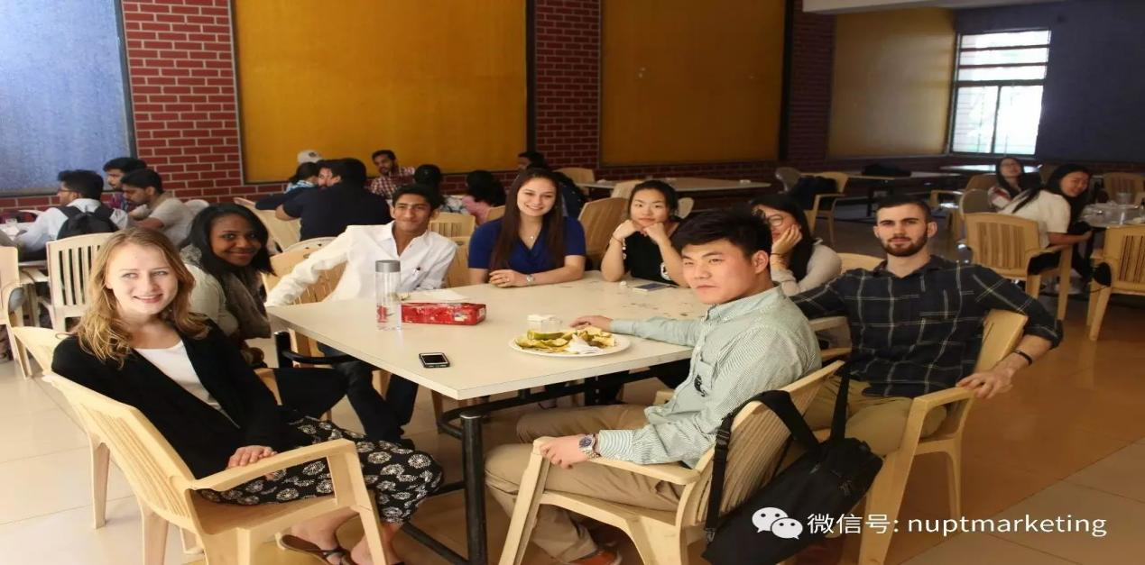

**美国波士顿项目简介**

第10期项目举办地：马萨诸塞大学洛威尔分校曼宁商学院（美国波士顿）

|  |
| --- |
| **项目时间**：2025年7月14日-2025年7月29日  **南京出发时间**：7月12日  **离开波士顿时间**：7月29日  **项目内容**：参与学生来自中国、美国、印度、圭亚那、泰国、日本等国家，大家合作完成教学、实践性课程（当地企业家讲座、演讲、辩论、案例分析、参观当地企业）。  授课交流语言：英语  **管理学院承担费用**：南京—波士顿往返交通费用  **自己承担费用**：波士顿学习期间的食宿费、学费共2500美元；签证费及代办费自行支付。  **限制**：限管理学院22-24级本科生、23-24级研究生申请  **提醒：**  往返美国波士顿的机票费用需要自己先垫付购买，返回南京后由学院报销；  如果有意向申请的同学，无论是否最终申请成功，请提前办好中国护照。（特别是户口不在江苏省的同学，手续办理需要时间，尽早办理）；  美国签证有拒签的风险！ |

 附件　美国项目英文介绍

**Announcing 2-week accelerated Workshops in summer 2025**

**Global Entrepreneurship and Innovation**

**Workshop**

Manning’s Global Entrepreneurship Exchange (GE2) is inviting students and faculty from UMass Lowell’s International Partners to attend 2-week class on Global Entrepreneurship and Innovation, Lowell, MA

The Course is designed to help students understand the importance of entrepreneurship and innovation in today's global economy and to cultivate an entrepreneurial mind-set, will work in inter-disciplinary, multi-cultural environments exploring problem solving techniques, opportunities identification, business concept development and venture planning using standard business model framework and bringing ideas to reality.

The Course will require students to work on real life technological projects and evaluate their commercialization potentials and opportunities. These projects will be sourced from a number of sources, including medical devices start-up ventures from M2D2, New Venture Development within UML’s CVIP, UML’s DifferenceMaker teams, students’ own ideas and other sources. Students will be required to explore opportunities on a global basis, thus will require to apply their own national/regional knowledge. Any venture is built on knowledge in multiple business areas such as engineering, marketing, operations, finance, etc.

The class will consist of about 50% working on real life projects and rest will be specific topic discussions, case studies, exercises, guest entrepreneurs and field visits. Each project team will be of 5 participants with a balance between discipline, nationality and academic level.

A Certificate will be awarded upon the completion of the workshop.

**Entrepreneurship topics**

• Essentials of Innovation and Entrepreneurship

• Business Model Generation

• Lean Launchpad

• Customer Discovery and development

• Team Building and Leadership

• Digital Marketing

• Making Presentations

• Financing New ventures

**Accommodations and Travels**

All International participants will stay in a brand new, state-of-the-art Residence Hall, fully equipped with all amenities. The Residence hall is comprised of primarily four- and six-person suites, with plenty of common space in each suite. There are also two huge

 lounges and kitchens on each floor, to go along with other quiet study areas spread throughout the building. Laundry equipment is available in the building. Accommodations will be made keeping in mind multi-cultural, multi-disciplinary intent of the program, that is, mix different nationalities and disciplines. This will offer an enriching experience beyond the class room. Take a virtual tour of our new facility https://www.uml.edu/student-services/reslife/residence-halls/River-Hawk-Village.aspx

**Program Fee**

$2,500 per participant which includes up to 16 days of accommodation, meals, local transportation (field trips, airport) and weekend events & activities.

**Apply Now**

Ｅach session will have no more than 60 participants. Apply now!

|  |
| --- |
| **4期在印度Hubli的交流项目报告视频**  中美印三国同学英文版本：https://v.qq.com/x/page/n0376evrqjp.html  南邮同学中文版本：https://v.qq.com/x/page/m0376le3q58.html  如果大家想了解更详细和生动的活动内容，可以关注**南邮管院分团委微信公众号**：**nuptgyftw**，查看2017年2月20日的历史消息，可以看到详细介绍。 |

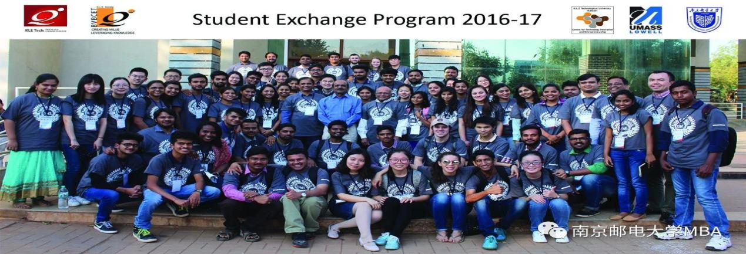

## 2025 Global Entrepreneurship and Innovation Workshop Project

